Variables
Catch the stars
Variables are like labelled boxes that have a label (name of the variable) so that we know what is stored inside (value of the variable). Variables store a value & the value can change
Example: program controlling the automated barriers in a car park could use variables to count cars in and out
Press space key to make a firework of stars; for Nano to catch!
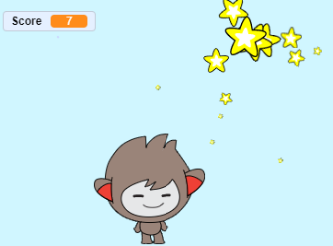
Get Ready
- Add Backdrop: Sky Sprites: Star, Nano
- Make a variable: Score
Add Your Code
- Nano: Place Nano at bottom left of the screen and make it follow the mouse-pointer
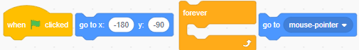
- Star: When space key pressed, make 100 clones of star like fireworks
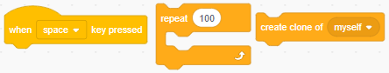
- Star: When a star is cloned, make it move and shrink in size
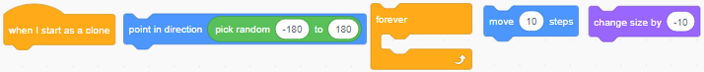
- Star: When a star clone touches Nano, increase score by 1 and delete clone
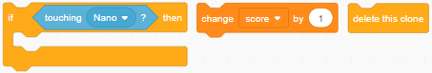
- Star: When a star clone touches edge, delete clone
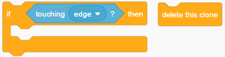
Try It Out!
- Press green flag - keep moving the mouse and pressing the space key. How many stars did you catch?
Challenge!
Spin star
Make each cloned star turn to follow the mouse pointer
High score
When score reaches 200, change backdrop to “Great catch” and stop game
Add Timer
Add a variable “timer” that goes up by 1 every 1 second. When timer reaches 30, change backdrop to “Time Up” and stop game
Rainbow – New Project
Add sprite - rainbow. When ‘rainbow’ sprite touches mouse-pointer, make clone of itself and play thunder sound. When it starts as a clone, go to a random position.
Test Yourself!
What is value of FUEL when key F is pressed?
